TRƯỜNG ĐẠI HỌC SÀI GÒN
KHOA CÔNG NGHỆ THÔNG TIN
-----***-----



MÔN: CÔNG NGHỆ PHẦN MỀM
ĐỀ TÀI: THUYẾT MINH TỰ ĐỘNG ĐA NGÔN NGỮ
THÀNH VIÊN NHÓM
3124411304 | Lê Đỗ Hoà Thương
3124411321 | Trần Minh Triết
3124411176 | Trần Thanh Nam

MỤC LỤC
1. PROJECT OVERVIEW & OBJECTIVES 3
1.1. Project Introduction 3
1.2. User Modules & Integrated Interface 3
2. FUNCTIONAL REQUIREMENTS & USE CASE DIAGRAMS 3
2.1. Overall Use Case Diagram (Mermaid Diagram) 3
2.2. Detailed Use Case Descriptions 5
2.2.1. User 5
2.2.2. COMMON & AUTHENTICATION 17
2.2.3. Manager 21
2.2.4. Admin 29
3. ARCHITECTURE & COMPONENT DIAGRAM 41
3.1. System Architecture Overview 41
3.2. Component Diagram 41
4. DEPLOYMENT DIAGRAM 42
4.1. Infrastructure Deployment Architecture 42
4.2. Deployment Diagram 42
5. ERD DATA MODEL (ENTITY RELATIONSHIP DIAGRAM) 43
6. LOAD PLAN & IMPLEMENTATION ROADMAP (PROJECT PLAN) 44
6.1. Implementation Milestones 44
6.2. Product Acceptance Criteria 44

1. PROJECT OVERVIEW & OBJECTIVES

1.1. Project Introduction
Saigon Audio Guide is a multilingual smart tourism support system serving visitors to the central area of District 1, Ho Chi Minh City. The system combines a GPS-enabled Web/Mobile application for tourists with a role-based Administration Portal for editing and approving audio guide content, managing the interactive map, and maintaining connected bus infrastructure.

1.2. User Modules & Integrated Interface
Visitor Module:
Interactive GPS positioning, landmark lookup, and route planning.
Listen to bilingual audio guides: Vietnamese / English.
Look up bus routes and the nearest stops.
Landmark Management Module:
The management team for each landmark can propose information changes, upload images, and update text and audio recordings in both English and Vietnamese.
Track proposal history.
System Administration Module:
Manage Admin and Manager accounts.
Compare two content versions and approve proposals from Managers.
Manage connected bus route data and view the system activity log.

2. FUNCTIONAL REQUIREMENTS & USE CASE DIAGRAMS

2.1. Overall Use Case Diagram (Mermaid Diagram)
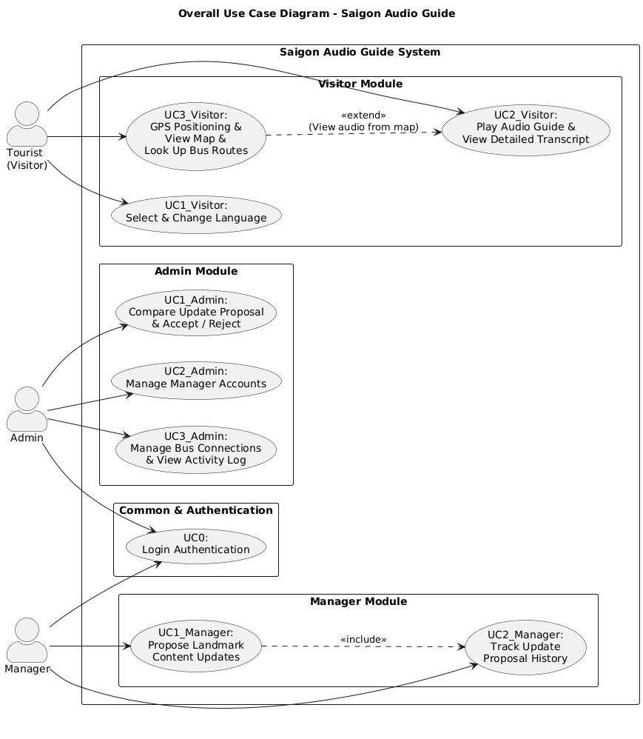

2.2. Detailed Use Case Descriptions

2.2.1. User

UC1_Visitor: Select & Change Language
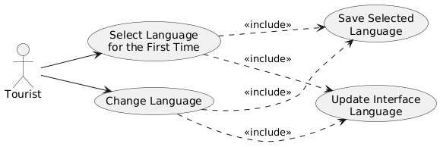
Use Case Number: | UC1_Visitor
Use Case Name: | Select & Change Language
Actor(s): | Tourist
Maturity: | Focused
Summary: | Allows users to select a language when opening the application for the first time and switch languages flexibly at any time using the interface toolbar.
Basic Course of Events: | Actor Action | System Response
Basic Course of Events: | 1. The user opens the application for the first time on the device (Web/Mobile).
Basic Course of Events: |  | 2. The system checks the local storage configuration and finds that no default language information is available.
Basic Course of Events: |  | 3. The system displays the Welcome Screen and asks the user to select the initial language: Vietnamese or English.
Basic Course of Events: | 4. The user selects the desired language and clicks “Continue”. [A1]
Basic Course of Events: |  | 5. The system records the selection and stores the language code (VI / EN) in the device's local storage. [E1]
Basic Course of Events: |  | 6. The system updates the entire interface to the selected language and navigates the user to the Tour Map screen.  Use Case ends.
Alternative Paths: | A1. Manually change language from the Header
Alternative Paths: | Actor Action | System Response
Alternative Paths: | On any screen, the user clicks the language switch button (VI / EN) on the Header.
Alternative Paths: |  | The system receives the language-switch event.
Alternative Paths: |  | The system updates the language dictionary and changes all interface text to the selected language.
Alternative Paths: |  | The system overwrites the new language code in the device's local storage. [E1]
Alternative Paths: |  | The system maintains the user's current screen state with the new language interface.  Return to the end step.
Exception Paths: | E1: Unable to save configuration to local storage
Exception Paths: | Actor Action | System Response
Exception Paths: | The user selects the language switch.
Exception Paths: |  | The system detects that the device storage is full or that private browsing blocks write access.
Exception Paths: |  | The system displays a warning message: "Unable to save the language setting permanently. Your selection will only apply during this session."
Exception Paths: | The user clicks "Understood" or closes the warning message.
Exception Paths: |  | The system temporarily applies the selected language to the current session interface without permanently saving it.  Return to the main flow.
Extension Points: | None
Triggers: | The user launches the application for the first time on the device, or clicks the language switch button [VI / EN] on the interface.
Assumptions: | The multilingual dictionary has already been configured and standardized in the application source code.
Preconditions: | The application has been successfully launched in the user's web browser or on their mobile device.
Post Conditions: | The language displayed throughout the application interface is updated consistently according to the user's selection.
Post Conditions: | The selected language code is successfully stored on the device for automatic application on subsequent visits.

Activity Diagram: UC1_Visitor: Select & Change Language

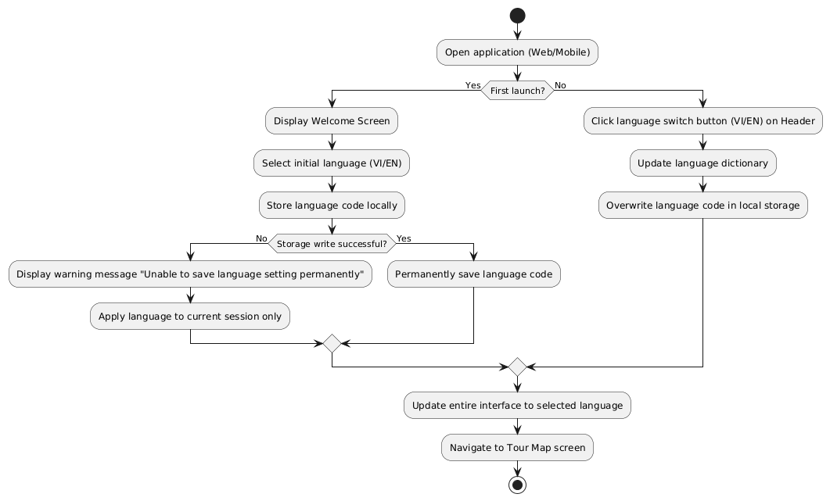

UC2_Visitor: Play Audio Guide & View Detailed Transcript
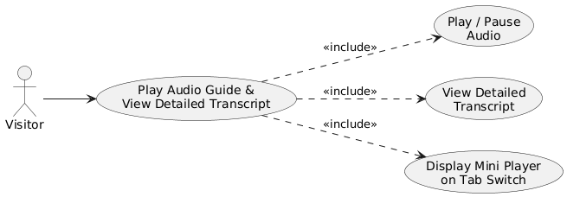
Use Case Number: | UC2_Visitor
Use Case Name: | Play Audio Guide & View Detailed Transcript
Actor(s): | Tourist
Maturity: | Focused
Summary: | Allows Visitors to select an audio guide from the Landmark List or Audio Guide tab, view the detailed transcript, and control playback/pause. When switching tabs, the mini player remains active and is automatically closed/hidden when the audio ends or the user closes it.
Basic Course of Events: | Actor Action | System Response
Basic Course of Events: | 1. The Visitor clicks the audio guide button for a landmark from the Landmark List or Audio Guide tab.
Basic Course of Events: |  | 2. The system loads the audio file and corresponding transcript in the current system language selected by the user in UC1. [E1]
Basic Course of Events: |  | 3. The system displays the Audio Player interface and starts playing the audio guide.
Basic Course of Events: |  | 4. The system displays the complete detailed transcript below the audio player.
Basic Course of Events: | 5. The Visitor clicks the Play/Pause button on the audio player.
Basic Course of Events: |  | 6. The system switches between continuing playback and pausing according to the user's action.
Basic Course of Events: | 7. The Visitor switches to another tab while the audio is playing.
Basic Course of Events: |  | 8. The system continues audio playback and displays a Mini Audio Player above the bottom navigation bar, showing the current landmark name and a Play/Pause button.
Basic Course of Events: | 9. The Visitor finishes listening to the audio guide. [A1]
Basic Course of Events: |  | 10. The system automatically stops playback and hides the Mini Audio Player from the screen. Use Case ends.
Alternative Paths: | A1. Manually close the Mini Audio Player
Alternative Paths: | Actor Action | System Response
Alternative Paths: | 1. While on another tab with the Mini Audio Player open, the Visitor clicks the close/stop audio button on the Mini Audio Player.
Alternative Paths: |  | 2. The system stops audio playback and immediately closes the Mini Audio Player.  Return to the end step.
Exception Paths: | E1. The user denies GPS permission
Exception Paths: | Actor Action | System Response
Exception Paths: |  | 1. The system cannot load the audio file from the server because the network connection is lost.
Exception Paths: |  | 2. The system displays a message: "Unable to load the audio file. Please check your network connection."
Exception Paths: |  | 3. The system displays the Transcript so that the Visitor can read the audio guide content.
Extension Points:
Triggers: | The Visitor selects an audio guide from the Landmark List or Audio Guide tab.
Assumptions: | The audio files and transcripts have already been stored in the system.
Preconditions: | The Visitor is on the Landmark List or Audio Guide tab.
Post Conditions: | The main audio player maintains a clear tab-switching flow, and the Mini Audio Player is closed/hidden according to the defined rules.

Activity Diagram: UC2_Visitor: Play Audio Guide & View Detailed Transcript
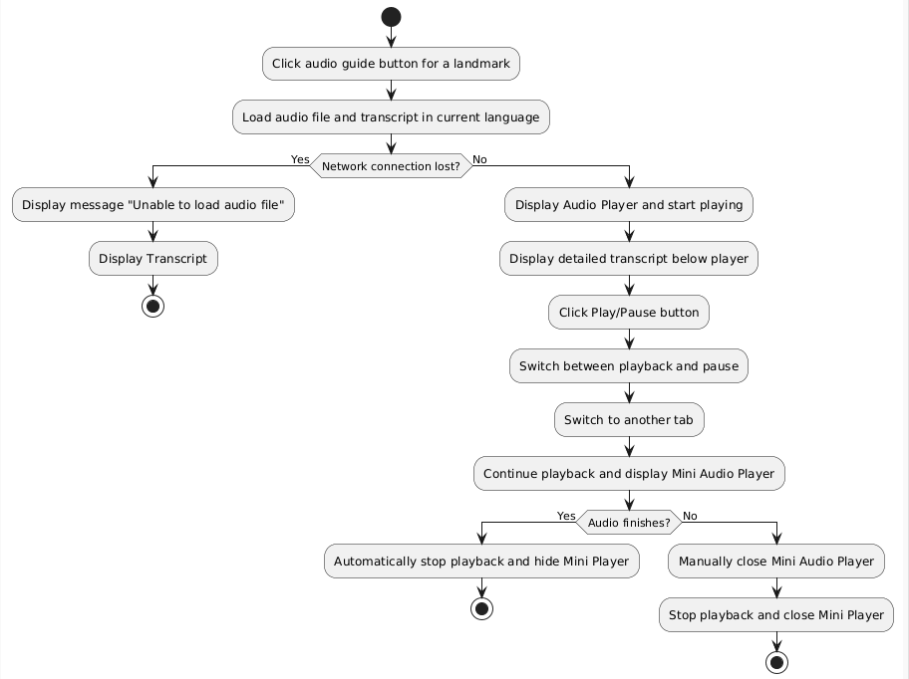

UC3_Visitor: GPS Positioning & View Map & Look Up Bus Routes
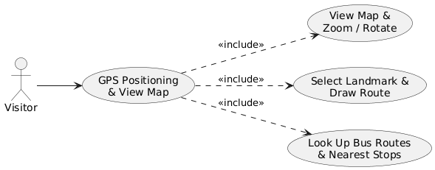
Use Case Number: | UC3_Visitor
Use Case Name: | GPS Positioning & View Map & Look Up Bus Routes
Actor(s): | Tourist
Maturity: | Focused
Summary: | Allows Visitors to view the interactive District 1 map, zoom/rotate the map, select a landmark to draw directions from the current GPS position, and look up bus routes and stops near the landmark.
Basic Course of Events: | Actor Action | System Response
Basic Course of Events: | 1. The Visitor accesses the Map screen in the application (Web/Mobile).
Basic Course of Events: |  | 2. The system displays the interactive map, identifies the blue dot representing the user's GPS position, and displays landmark markers.
Basic Course of Events: | 3. The Visitor selects a landmark marker on the map.
Basic Course of Events: |  | 4. The system highlights the selected landmark marker and opens the navigation panel outside the map.
Basic Course of Events: | 5. The Visitor clicks the "Start" navigation button.
Basic Course of Events: |  | 6. The system draws a direction route (Polyline) connecting the user's GPS position to the selected landmark on the map.
Basic Course of Events: | 7. The Visitor clicks the "Bus" button. [A1]
Basic Course of Events: |  | 8. The system displays the list of bus routes serving the landmark, together with the names of nearby stops. [E1]  Use Case ends.
Alternative Paths: | A1. Look up bus routes directly from the bus connection button in the corner of the map.
Alternative Paths: | Actor Action | System Response
Alternative Paths: | 1. The Visitor clicks the floating "Bus Connection" button in the corner of the map.
Alternative Paths: |  | 2. The system opens a bus lookup popup and allows the Visitor to quickly change the landmark through a Dropdown menu.
Exception Paths: | E1. No connected bus route data is available.
Exception Paths: | Actor Action | System Response
Exception Paths: | The Visitor selects bus information for a landmark for which route data has not been registered.
Exception Paths: |  | 2. The system displays a message: "No bus route information is available for this landmark."
Extension Points: | UC2. The Visitor can click the view details button in the list to switch to the audio guide.
Triggers: | The Visitor interacts with the map or destination list.
Assumptions: | The mobile device supports location services, or the system uses a default location point in District 1.
Preconditions: | The Visitor has accessed the Map screen.
Post Conditions: | The corresponding direction route or bus route list is displayed visually.
Reference: | None

Activity Diagram: UC3_Visitor: GPS Positioning & View Map & Look Up Bus Routes
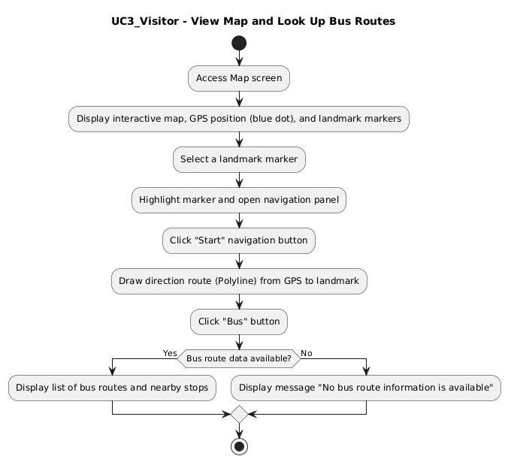

2.2.2. COMMON & AUTHENTICATION

UC0: Login Authentication
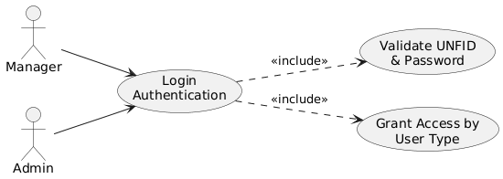
Use Case Number: | UC0
Use Case Name: | Login Authentication
Actor(s): | Manager, Admin
Maturity: | Focused
Summary: | All users log in to the Administration Portal. The available functions depend on the User Type, i.e., Admin or Manager.
Basic Course of Events: | Actor Action | System Response
Basic Course of Events: | 1. The Manager/Admin enters the UNFID and Password.
Basic Course of Events: |  | 2.The system will retrieve the actor’s name and User Type from the database for the supplied UNFID and Password thus beginning a Session.  [E1], [E2]
Basic Course of Events: |  | 3. Feature availability reflects the user type.  Manager have access to:  Edit place’s information  delete/change audio  Log Off  Admin have access to:  Listen Management  Manager account Management  Places Management  Map Management  Bus Line Mnagement  Log Off
Basic Course of Events: | . | 4. The system redirects the actor to the Home page.
Alternative Paths: | None
Exception Paths: | E1. If the system cannot find the UNFID in the database, the system informs the actor that their UNFID cannot be found and returns the actor to the beginning of the course of events.  E2. If the system finds the UNFID in the database but the supplied Password does not match the Password associated with the UNFID, the system informs the actor that their Password is incorrect and returns the actor to the beginning of the course of events.
Extension Points: | None
Triggers: | The actor visits the Administration Portal but has not yet begun a Session.  The actor's Session has timed out as a result of inactivity.  The actor has ended a Session by selecting Log Off.
Assumptions: | Manager and Admin accounts have already been registered in the system.  Each account has an assigned User Type.
Preconditions: | The actor is visiting the Administration Portal but does not have an active Session. Therefore, the actor has been redirected to the Login page.
Post Conditions: | The actor has an active Session.  The actor is redirected to the Home page.  The actor has access to the features appropriate to their User Type.
Reference: | The actor has an active Session.  The actor is redirected to the Home page.  The actor has access to the features appropriate to their User Type.

Activity Diagram: UC0: Login Authentication
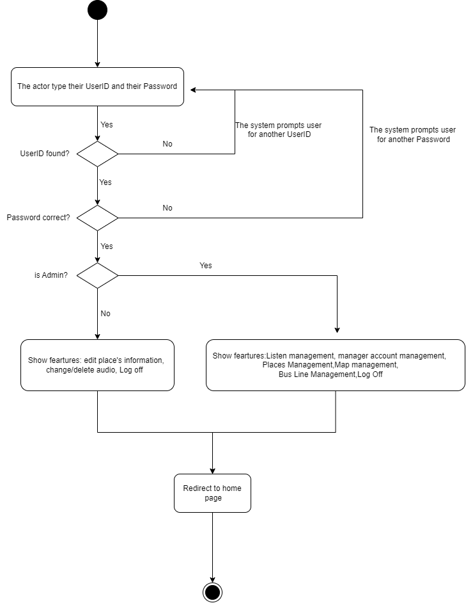

2.2.3. Manager

UC1_Manager: Propose Landmark Content Updates
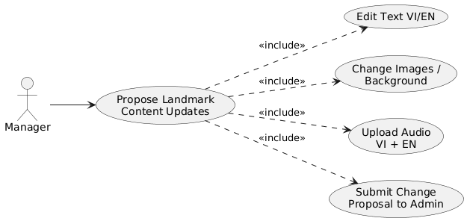
Use Case Number: | UC1_Manager
Use Case Name: | Propose Landmark Content Updates
Actor(s): | Manager
Maturity: | Focused
Summary: | Allows a Manager account to edit text content, background, gallery images, and upload new audio guide files to submit an approval request to the Admin. The system applies a strict content constraint: when editing the audio guide transcript, the Manager must upload both new Audio files, Vietnamese and English.
Basic Course of Events: | Actor Action | System Response
Basic Course of Events: | 1. The Manager logs in successfully and is automatically directed to the Management Portal for the authorized landmark.
Basic Course of Events: |  | 2. The system displays a scrolling editing interface synchronized with the Visitor view and loads the current data.
Basic Course of Events: | 3. The Manager changes the Vietnamese or English audio guide transcript.
Basic Course of Events: |  | 4. The system flags the audio guide transcript as modified.
Basic Course of Events: | 5. The Manager selects and uploads a new Vietnamese Audio file and a new English Audio file.
Basic Course of Events: |  | 6. The system receives the files and updates the status to indicate that both audio files have been uploaded.
Basic Course of Events: | 7. The Manager clicks the "Submit Change Proposal to Admin" button. [A1]
Basic Course of Events: |  | 8. The system checks the constraints and verifies that both Audio files have been uploaded. [E1]
Basic Course of Events: |  | 9. The system creates a new proposal record with a proposal ID, assigns the Pending Approval status, saves it to the database, and displays a successful submission message.
Basic Course of Events: |  | 10. The system automatically switches to the "Proposal History" tab for the Manager to track progress.  Use Case ends
Alternative Paths: | A1. Preview the interface displayed to Visitors
Alternative Paths: | Actor Action | System Response
Alternative Paths: | 1. Before deciding to submit the proposal, the Manager clicks the "Preview Changes" button.
Alternative Paths: |  | 2. The system opens a Modal window simulating the Visitor interface with the exact background, title, and newly edited content.
Alternative Paths: | 3. The Manager reviews the interface and clicks the Modal close button to return to the main flow.
Exception Paths: | E1. Audio constraint violation when changing text (submission blocked if audio is missing)
Exception Paths: | Actor Action | System Response
Exception Paths: | 1. The Manager uploads only one Audio file (or no file) and clicks "Submit Proposal".
Exception Paths: |  | 2. The system detects a violation because the required new audio files are missing.
Exception Paths: |  | 3. The system blocks submission and displays a Popup warning: "CONTENT CONSTRAINT: When changing the audio guide transcript, BOTH new Audio files (Vietnamese and English) must be uploaded!"
Exception Paths: | 4. The Manager confirms the warning, uploads the missing Audio file, and repeats Step 7.
Extension Points:
Triggers: | The Manager clicks the "Submit Change Proposal to Admin" button on the update screen.
Assumptions: | The Manager account has been created and assigned to the correct landmark.
Preconditions: | The Manager has logged in successfully.
Post Conditions: | The update request is recorded with Pending Approval status and appears on the Admin approval queue.
Reference: | None

Activity Diagram: UC1_Manager: Propose Landmark Content Updates
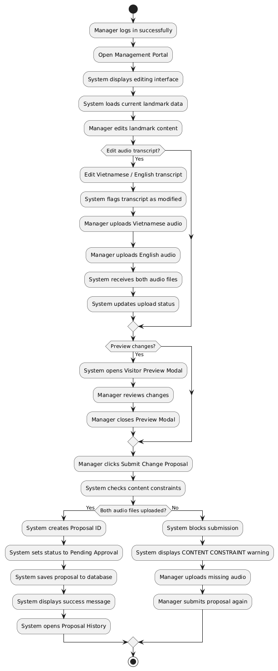

UC2_Manager: Track Update Proposal History
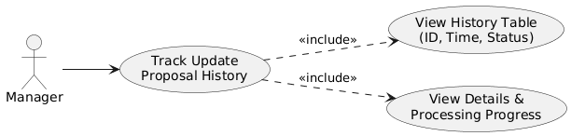
Use Case Number: | UC2_Manager
Use Case Name: | Track Update Proposal History
Actor(s): | Manager
Maturity: | Focused
Summary: | Allows the Manager, after successfully logging in, to view submitted content update proposals sent to the Admin and track their approval status in real time (Pending Approval / Accepted / Rejected), together with timestamps and detailed notes.
Basic Course of Events: | Actor Action | System Response
Basic Course of Events: | 1. The Manager logs in successfully and switches to the "Proposal History" tab on the Management Portal.
Basic Course of Events: |  | 2. The system loads the list of proposals for the landmarks assigned to the Manager. [E1]
Basic Course of Events: |  | 3. The system displays a history table with columns for Proposal ID, Submission Time, Changed Content, and Approval Status, together with status badges for pending, accepted, and rejected.
Basic Course of Events: | 4. The Manager views the details and processing progress of each proposal.
Basic Course of Events: |  | 5. The system keeps the display available for the Manager to continue monitoring.  Use Case ends
Alternative Paths: | None
Exception Paths: | E1. No proposal history has been created
Exception Paths: | Actor Action | System Response
Exception Paths: | 1. The Manager has never submitted an update proposal.
Exception Paths: |  | 2. The system displays an empty table with a message: "No change proposals have been recorded."
Extension Points:
Triggers: | The Manager selects the "Proposal History" tab on the navigation bar or is automatically redirected there after successfully submitting UC1_Manager.
Assumptions: | Proposal history data is accurately synchronized in real time from the database.
Preconditions: | The Manager has logged in successfully.
Post Conditions: | The proposal history and approval statuses from the Admin are displayed transparently to the Manager.
Reference:

Activity Diagram: UC2_Manager: Track Update Proposal History

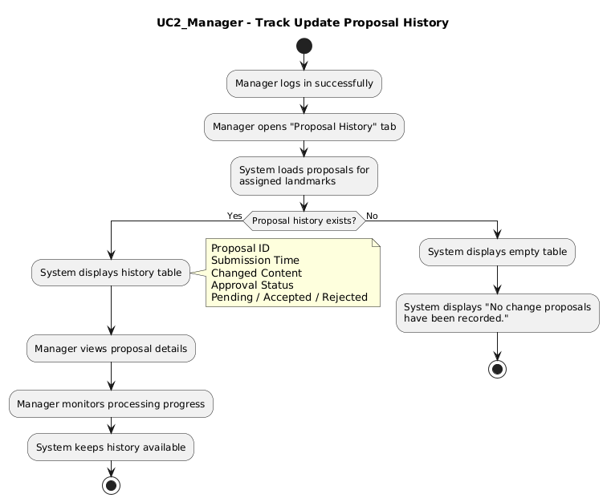

2.2.4. Admin

UC1_Admin: Compare Update Proposal & Accept / Reject Proposal
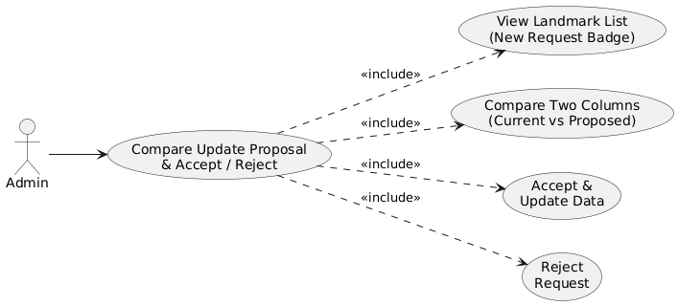
Use Case Number: | UC1_Admin
Use Case Name: | Compare Update Proposals & Accept / Reject Proposals
Actor(s): | Admin
Maturity: | Focused
Summary: | Allows the Admin, after successfully logging in, to view update proposals from Managers and open a side-by-side comparison interface between the Current Version and Proposed Version for each item (Title, Subtitle, Coordinates, Vietnamese/English Audio, Vietnamese/English Text, Image Set), then decide to Accept or Reject the proposal.
Basic Course of Events: | Actor Action | System Response
Basic Course of Events: | 1. The Admin logs in successfully and accesses the Landmark Management or Statistics page on the Admin Portal.
Basic Course of Events: |  | 2. The system displays the list of landmarks with the status badge "New Request Available" [E1].
Basic Course of Events: | 3. The Admin clicks the "View Request" button for a landmark with a pending request.
Basic Course of Events: |  | 4. The system opens a two-column comparison Modal: the left column displays the current version and the right column displays the proposed version.
Basic Course of Events: | 5. The Admin compares the differences between the two versions (text, audio files, images).
Basic Course of Events: | 6. The Admin clicks the "Accept & Update" button to approve the new content. [A1]
Basic Course of Events: |  | 7. The system overwrites the official data displayed to Visitors with the new version (the Vietnamese version updates the Vietnamese content, and the English version updates the English content).
Basic Course of Events: |  | 8. The system removes the pending request and changes the proposal status to approved.
Basic Course of Events: |  | 9. The system records the event in the Activity Log and displays a success Toast notification.  Use Case ends.
Alternative Paths: | A1. Admin rejects the update proposal
Alternative Paths: | Actor Action |  | System Response
Alternative Paths: | 1. The Admin clicks Reject Request.
Alternative Paths: |  |  | 2. The system discards the proposed version and keeps 100% of the existing data displayed to Visitors unchanged.
Alternative Paths: |  |  | 3. The system changes the proposal status to rejected, records the action in the log, and displays a rejection notification.  Return to the end step.
Exception Paths: | E1. Request has been cancelled or no longer exists
Exception Paths: | Actor Action | System Response
Exception Paths: | 1. The Admin opens a request, but the proposal data has been changed/cancelled by another system process.
Exception Paths: |  | 2. The system displays a Toast notification: "This landmark currently has no new request." and closes the Modal
Extension Points:
Triggers: | The Admin clicks the "View Request" button in the landmark list.
Assumptions: | Comparison data is fully standardized in both Vietnamese and English.
Preconditions: | At least one Manager proposal is in Pending Approval status and the Admin has successfully logged in.
Post Conditions: | The data displayed to Visitors is either updated or remains unchanged.
Reference:

Activity Diagram: UC1_Admin: Compare Update Proposal & Accept / Reject Proposal
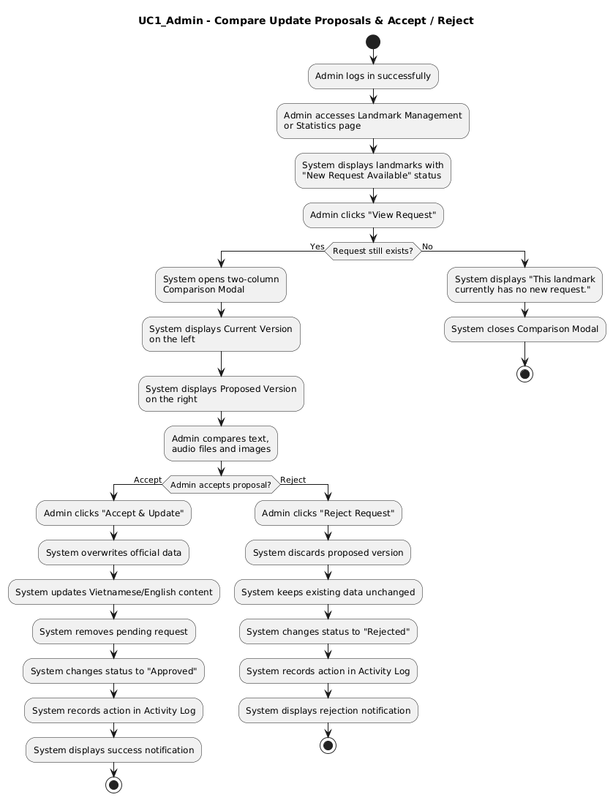

UC2_Admin: Manage Manager Accounts

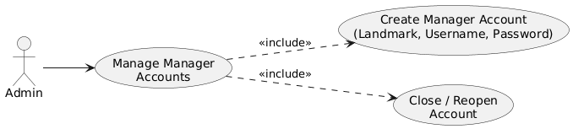
Use Case Number: | UC2_Admin
Use Case Name: | Manage Manager Accounts
Actor(s): | Admin
Maturity: | Focused
Summary: | After successfully logging in, the Admin creates a new Manager account for each responsible landmark management team and can also edit displayed information or temporarily deactivate (Close) / reactivate (Open) an account when necessary.
Basic Course of Events: | Actor Action | System Response
Basic Course of Events: | 1. The Admin logs in successfully, switches to the "Account Management" tab, and clicks the "Create Manager Account" button. [A1]
Basic Course of Events: |  | 2. The system displays a Modal form containing: Assigned Landmark, Username, and Initial Password.
Basic Course of Events: | 3. The Admin enters all required information and clicks the "Create Account" button.
Basic Course of Events: |  | 4. The system validates the information and checks whether the username already exists. [E1]
Basic Course of Events: |  | 5. The system creates the new Manager account with active = true and assigns the Manager role.
Basic Course of Events: |  | 6. The system updates the account list, records the action in the Activity Log, and displays a success Toast notification. Use Case ends.
Alternative Paths: | A1. Temporarily deactivate or reactivate a Manager account
Alternative Paths: | Actor Action |  | System Response
Alternative Paths: | 1. The Admin finds the account in the list and clicks "Close Account" or "Reopen".
Alternative Paths: |  |  | 2. The system toggles the account's active status (active = ! active).
Alternative Paths: |  |  | 3. The system records the action in the log and immediately updates the table interface.
Exception Paths: | E1. Username already exists in the system
Exception Paths: | Actor Action | System Response
Exception Paths: | 1. The Admin enters a username that duplicates an existing account in the database.
Exception Paths: |  | 2. The system detects the duplicate and displays a Toast notification: "This username already exists. Please choose another name."
Exception Paths: | 3. The Admin changes to another username and continues.
Extension Points:
Triggers: | The Admin clicks action buttons on the Account Management page.
Assumptions: | The main Admin account (Super Admin) is protected by the system and cannot be deactivated.
Preconditions: | The Admin has successfully logged in.
Post Conditions: | The user account list is accurately updated in the database.
Reference:

Actiity Diagram: UC2_Admin: Manage Manager Accounts
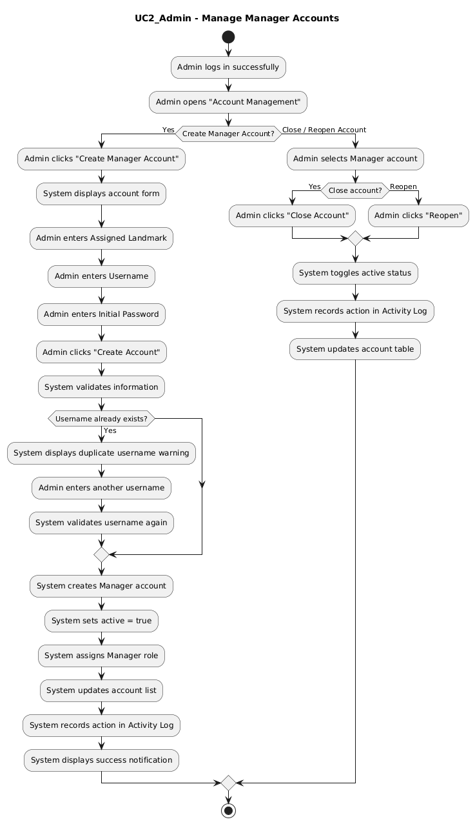

UC3_Admin: Manage Bus Connections & View Activity Log
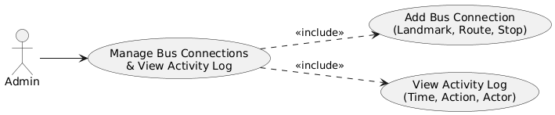
Use Case Number: | UC3_Admin
Use Case Name: | Manage Bus Connections & View Activity Log
Actor(s): | Admin
Maturity: | Focused
Summary: | Allows the Admin, after successfully logging in, to add/delete bus routes and stops near landmarks to support Visitor travel, while also viewing the system-wide activity log.
Basic Course of Events: | Actor Action | System Response
Basic Course of Events: | 1. The Admin logs in successfully, selects the "Bus Connections" tab, and clicks the "Add Bus Connection" button. [A1]
Basic Course of Events: |  | 2. The system displays a Modal form containing: Landmark, Bus Route Number, and Nearby Stop Name.
Basic Course of Events: | 3. The Admin enters the route/stop information and clicks "Save Connection".
Basic Course of Events: |  | 4. The system validates the information and checks whether the connection is duplicated. [E1]
Basic Course of Events: |  | 5. The system adds the bus information to the corresponding landmark.
Basic Course of Events: |  | 6. The system automatically records the action in the "Activity Log" and updates the displayed list.  Use Case ends.
Alternative Paths: | A1. View the system activity log
Alternative Paths: | Actor Action | System Response
Alternative Paths: | 1. The Admin selects the "Activity Log" tab.
Alternative Paths: |  | 2. The system retrieves and displays a list of recent actions (Time, proposal approval actions, account creation, and bus connection edits).
Exception Paths: | E1. Missing information or existing bus route connection
Exception Paths: | Actor Action | System Response
Exception Paths: | 1. The Admin leaves the route number/stop name blank or enters a route already registered for that landmark.
Exception Paths: |  | 2. The system displays a Toast warning: "Please enter the route number and stop name." or "This route and stop connection already exists."
Exception Paths: | 3. The Admin adjusts the data and saves it again.
Extension Points:
Triggers: | The Admin clicks action buttons on the Bus Connections or Activity Log tab.
Assumptions: | Bus route data is validated before being published to the user application.
Preconditions: | The Admin has successfully logged in.
Post Conditions: | Bus route data is updated and the action is fully recorded in the log.
Reference:

Activity Diagram: UC3_Admin: Manage Bus Connections & View Activity Log
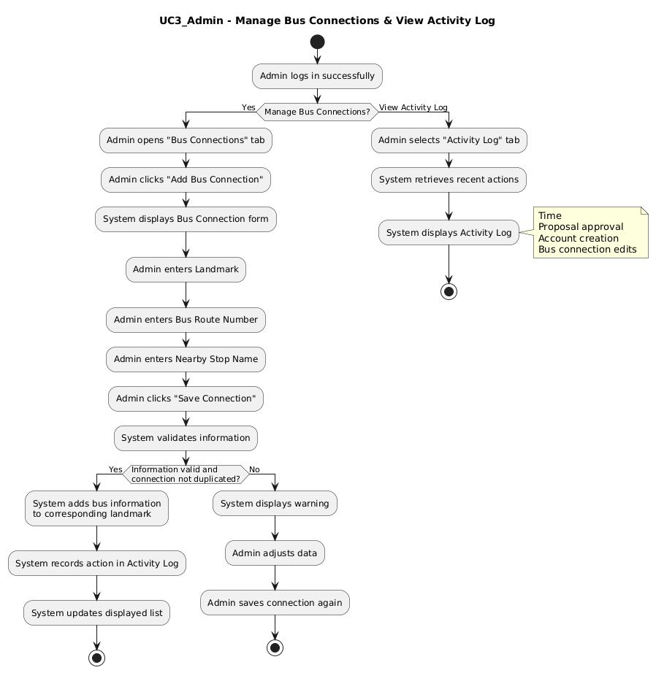

3. ARCHITECTURE & COMPONENT DIAGRAM

3.1. System Architecture Overview
The Saigon Audio Guide system is designed based on a 3-Tier Architecture integrated with modern Microservices/RESTful Services patterns.
Presentation Layer:
Visitor App (Web/Mobile Progressive Web App): Built with React / React Native & Vite, optimized for real-time GPS tracking, Leaflet/Mapbox maps, and a seamless Audio Engine.
Administration Portal (Admin & Manager): Built with React Dashboard featuring a side-by-side data comparison view.
Business Logic Layer / Application Layer:
Core API Gateway / Node.js Express Application: Handles incoming HTTP requests and routing
Authentication & Authorization Service: Manages JWT (JSON Web Tokens), password hashing (Bcrypt), and Role-Based Access Control (RBAC) for Admin and Manager accounts
Content & Approval Management Service: Manages audio guide contents, update proposal approval workflows, and enforces the strict two-audio constraint rule (Vietnamese/English).
Map & Route Service: Provides point-of-interest coordinates, navigation polyline calculation, and bus connection data
Data Access Layer:
Relational Database (PostgreSQL / SQLite): Stores structured data (Users, Places, Bus Lines, Proposals, and Activity Logs).
Cloud Object Storage (AWS S3 / Firebase Storage): Stores media files (Gallery images, audio files in MP3 format for VI and EN).

3.2. Component Diagram
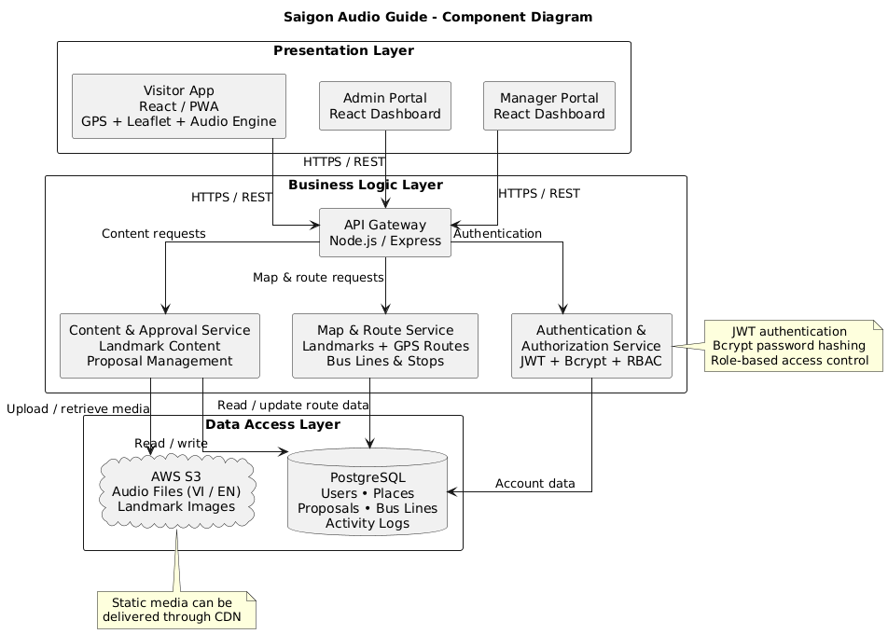

4. DEPLOYMENT DIAGRAM

4.1. Infrastructure Deployment Architecture
The system is deployed on a cloud computing infrastructure with scalable components:
Client Devices:
Visitor Mobile / Web Browser (Access via HTTPS with active GPS location)
Admin & Manager PC Web Browser.
Web Content Delivery Network (CDN) & Load Balancer:
Cloudflare CDN: Delivers static assets (React App, Audio, Images) to end-users with low latency.
Nginx Reverse Proxy / Load Balancer: Manages HTTPS request traffic, load balancing, and SSL/TLS security.
Application Server Cluster: Docker Containers (Node.js/Express Runtime): Packaged application running on AWS EC2 or DigitalOcean Droplets, managed by PM2 or Kubernetes.
Database & Storage Infrastructure:
Managed Relational Database: PostgreSQL/SQLite database with automated daily backups.
AWS S3 / Cloud Storage Bucket: Cloud infrastructure hosting media files (.mp3 audio and .jpg/.png images).

4.2.Deployment Diagram
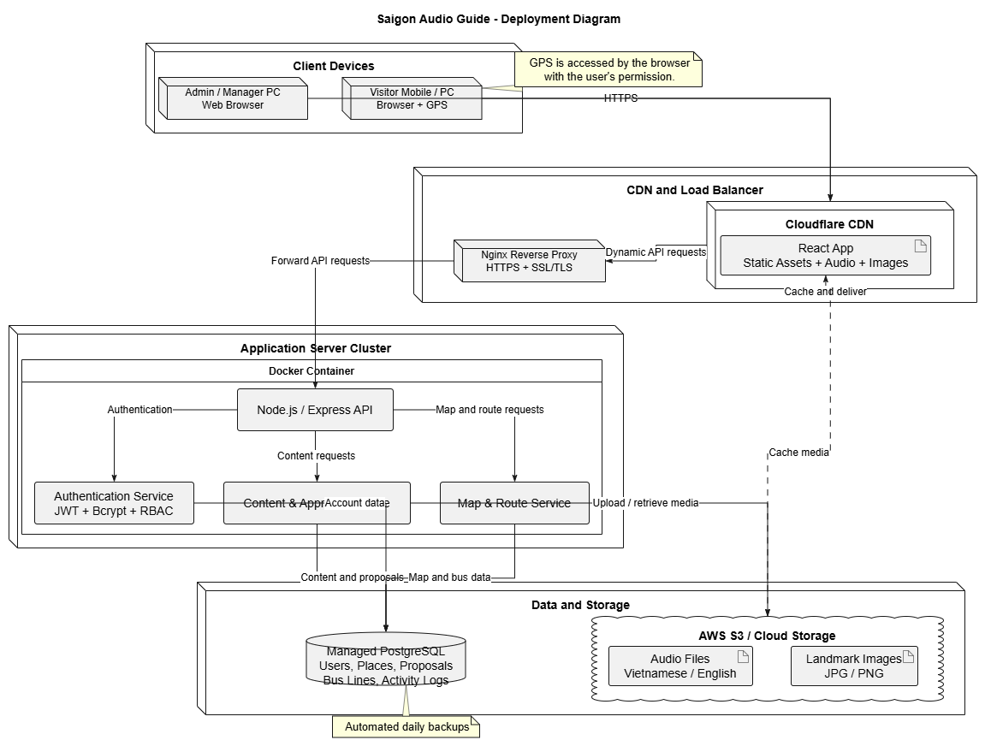

5. ERD DATA MODEL (ENTITY RELATIONSHIP DIAGRAM)

1. ERD Content
I derived the entities from the use cases (UC0, UC1–3 for Visitor/Manager/Admin) and the architecture section (PostgreSQL/SQLite storing Users, Places, Bus Lines, Proposals, Activity Logs; media files stored on S3).
Entities
Entity | Description | Key Attributes
USERS | Admin/Manager accounts (UC0, UC2_Admin) | user_id (PK), username (UNIQUE), password_hash (Bcrypt), role (ADMIN/MANAGER), is_active, is_super_admin, landmark_id (FK, null for Admin), created_at
LANDMARKS | Landmarks and the official content shown to Visitors | landmark_id (PK), title_vi/en, subtitle_vi/en, latitude, longitude, background_image_url, description_vi/en, transcript_vi/en, audio_vi_url, audio_en_url, has_pending_request, updated_at
LANDMARK_IMAGES | Gallery images of a landmark | image_id (PK), landmark_id (FK), image_url, sort_order
PROPOSALS | Manager update proposals (UC1_Manager, UC1_Admin) | proposal_id (PK), landmark_id (FK), manager_id (FK), status (PENDING/ACCEPTED/REJECTED), proposed content fields (title, subtitle, coordinates, description, transcript, VI/EN audio, background), review_note, reviewed_by (FK), submitted_at, reviewed_at
PROPOSAL_IMAGES | Proposed image set attached to a proposal | proposal_image_id (PK), proposal_id (FK), image_url, sort_order
BUS_ROUTES | Bus routes | route_id (PK), route_number (UNIQUE)
BUS_STOPS | Bus stops | stop_id (PK), stop_name, latitude, longitude
LANDMARK_BUS_  CONNECTIONS | Landmark – route – stop link (UC3_Admin) | connection_id (PK), landmark_id (FK), route_id (FK), stop_id (FK), UNIQUE(landmark_id, route_id, stop_id) to prevent duplicates (E1)
ACTIVITY_LOGS | Activity log (proposal approvals, account creation, bus edits) | log_id (PK), user_id (FK), action_type, target_type, target_id, description, created_at
ANALYTICS_VISITORS | Visitor analytics records used to track application usage and visits | Visitor analytics identifier (PK), visitor/session reference, visit metadata, timestamps; exact column names follow the ERD diagram
AUDIO_LISTENS | Records audio-guide listening activity for usage statistics | Audio listen identifier (PK), landmark reference (FK), visitor/session reference, audio language, listening timestamp; exact column names follow the ERD diagram
DEVICE_SESSIONS | Tracks application sessions associated with visitor device | Device session identifier (PK), device/session reference, activity timestamps, session metadata; exact column names follow the ERD diagram

Relationships
- LANDMARKS 1 – N LANDMARK_IMAGES
- LANDMARKS 1 – N USERS (a landmark can have multiple Managers; Admins are not tied to a landmark)
- LANDMARKS 1 – N PROPOSALS
- USERS 1 – N PROPOSALS (Manager submits)
- USERS 1 – N PROPOSALS (Admin reviews, via reviewed_by)
- PROPOSALS 1 – N PROPOSAL_IMAGES
- LANDMARKS / BUS_ROUTES / BUS_STOPS each 1 – N LANDMARK_BUS_CONNECTIONS (the junction table resolves the many-to-many relationship between landmarks, routes, and stops)
- USERS 1 – N ACTIVITY_LOGS
Notes: The Visitor's language choice (VI/EN) is stored in the device's local storage (UC1_Visitor), so it has no table in the database. The constraint "editing the transcript requires uploading both audio files" should be enforced in the service layer, and can also be added as a CHECK on PROPOSALS.

2. Mermaid Code

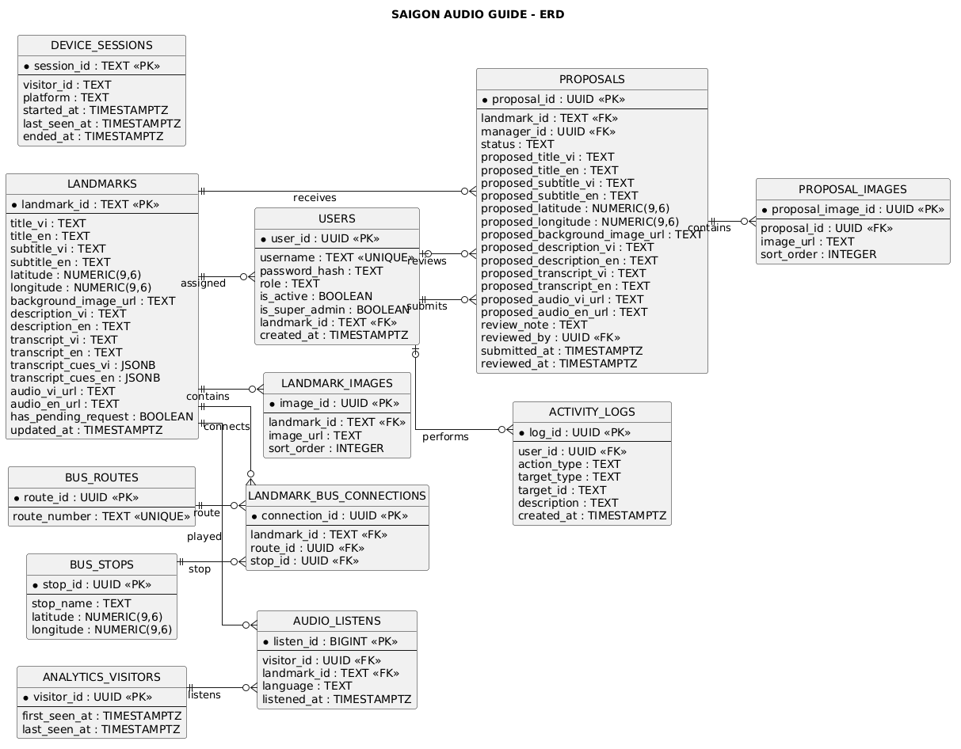

6. LOAD PLAN & IMPLEMENTATION ROADMAP (PROJECT PLAN)

6.1. Implementation Milestones
Phase | Key Tasks | Duration | Deliverables
1 | Requirements analysis, PRD completion, UI/UX Mockup | T1 - T2  (2 weeks) | PRD, Complete HTML/CSS Prototype
2 | Build Database, Core API Backend, Authentication Service | T3 - T5  (3 weeks) | Backend REST APIs, ERD DB Schema
3 | Develop Client App (GPS Web/Mobile) & Audio Engine | T6 - T8  (3 weeks) | Web Visitor with GPS & Audio playback
4 | Develop Admin & Manager Portal, Compare View feature | T9 - T11  (3 weeks) | Completed Admin & Manager Portal
5 | Integration, Testing (System Integration Testing, UAT) | T12 - T13  (2 weeks) | Test Case Report, Bug Fixes
6 | Deploy Cloud infrastructure, Training & Handover | T14  (1 week) | Officially operational system (Go-Live)

6.2. Product Acceptance Criteria
Visitor App Performance: Page load time under 1.5s; smooth GPS position updates; smooth audio playback without interruptions.
Content Approval Process: Admin can visually compare the two versions and update data in real time on the Visitor App immediately after selecting Accept.
Data Accuracy: Ensure the content constraint that when the audio guide transcript is edited, both Audio files (Vietnamese/English) must be updated.

